**CENWP-OD-JMay 17, 2023**

**MEMORANDUM FOR THE RECORD**

**SUBJECT: 23JDA18 MU12B Orifice Gate Broken**

On Wednesday May 10, during daily gatewell inspections, three juvenile salmonid mortalities were found in MU12 B gatewell. The morts were removed and identified as three clipped chinook salmon, they were scanned for PIT tags.

On Thursday and Friday no additional mortalities were observed, and the situation was monitored closely over the weekend.

On Monday May 15, 14 more morts were found and removed from MU12B (13 clipped yearling chinook, and 1 unclipped sockeye), they were scanned for pit tags. At that time John Day maintenance deployed the camera train to inspect the orifice, vertical barrier screen and submersible traveling screen. High turbidity made the inspection difficult, and the screen was pulled out to verify it was in working condition, which it was. The fish orifice was manually cycled several times to clear any potential blockage and the unit remained in service.

On Tuesday May 16, six clipped juvenile chinook salmon were removed from the gatewell. Again, the camera train was used to investigate the problem, and with lower turbidity and improved visibility, it was found that the orifice slide gate had broken off from the shaft and blocked the opening, therefore there was no egress route from the gatewell. MU12 was forced out of service at 1203 because of the problem. Maintenance crews dipped the gatewell to remove additional live fish and recover any additional mortalities. Additional morts included: 31 clipped yearling chinook and 1 clipped coho. Live fish removed included: An estimated 6,000 salvaged smolts were rescued and released into the adjacent gatewell, and 27 juvenile lampreys. The problem was quickly identified and repaired once the gatewell was dewatered, and the unit was returned to service at 2011.

1. Species – Chinook and Sockeye
2. Origin – clipped and unclipped
3. Length – Smolts
4. Marks and tags – No tags detected
5. Marks and Injuries found on carcass – various- bacteria, predator marks, body injury, descaling.
6. Cause and Time of Death – no egress from gatewell
7. Future and Preventative Measures – Unit priority will be switched to last on/first off of any suspected unit with an egress problem until a determination can be made of the cause of mortalities in the gatewell. Additionally, John Day fisheries is researching better cameras for inspections during periods of high turbidity.

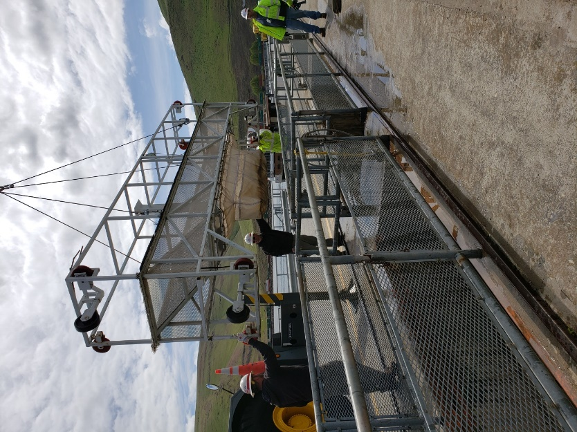 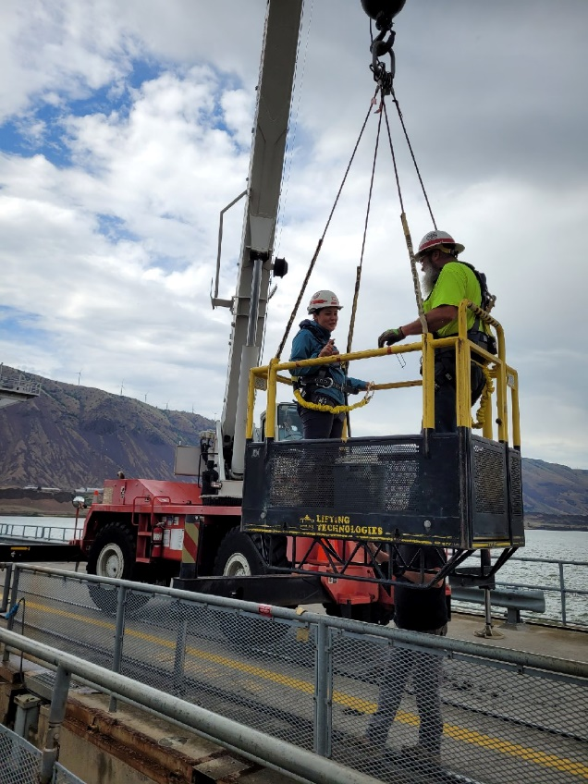

MU12B being dipped to remove fish. Fish recovery on bulkhead.

Sincerely,

JDA Project Fisheries